Enhancing Stock Price Prediction with Hybrid LSTM-GRU Architectures and Attention Mechanisms on Grouped Time-Series Data.

By
Oluomachukwu Otuadinma

A Master’s Dissertation
Submitted to the Department of Computing, Data Science and Artificial Intelligence
Goldsmiths University of London
In Fulfilment of a Master's Degree
September 2025

Supervised by Dr V L Raju Chinthalapati

Abstract
This study advances grouped time-series forecasting by integrating LSTM and GRU architectures with attention mechanisms to enhance stock price prediction accuracy and model interpretability. Building on Lawi et al. (2022), who demonstrated that GRUs outperform LSTMs on grouped financial series, I evaluate three hybrid model families, LSTM to GRU, GRU to LSTM, and Parallel LSTM+GRU across four NASDAQGS equities, using sliding 40-day windows to predict the 41st day and 4 neural block architectures. The methodology incorporates per-ticker, leak-free scaling and walk-forward evaluation to ensure robust and unbiased results. Models are benchmarked against naive baselines and a compact Transformer architecture representing a modern sequence learning approach. Results show that the Parallel LSTM+GRU hybrid consistently delivers superior predictive performance, reducing mean absolute percentage errors (MAPE) by up to 15% compared to standalone models. The incorporation of attention mechanisms aimed at highlighting key temporal features within grouped stock data unexpectedly diminished predictive performance. This decline is attributed to the initial grouping strategy, which combined stocks with vastly different price ranges (high and low earners). Such grouping introduced excessive noise, causing the attention-enhanced models to produce smoothed, averaged predictions that failed to capture individual stock dynamics effectively. Similarly, the Transformer baseline struggled to extract meaningful patterns, potentially due to suboptimal modelling choices or insufficient tuning, further highlighting challenges in applying modern sequence models directly to heterogeneous grouped financial time series. These findings highlight the effectiveness of hybrid RNN architectures for capturing complex temporal dynamics in financial data and emphasise the potential, yet cautious utility, of attention-based enhancements.

Introduction
Building on the work of Lawi et al. (2022), who demonstrated the effectiveness of grouped time-series forecasting using separate LSTM and GRU models and found that GRUs were generally more accurate than LSTMs on their dataset, this study investigates whether hybrid LSTM–GRU architectures with attention can further improve stock price prediction and interpretability. I explore whether combining recurrent cells can exceed the strongest standalone GRU baseline and whether attention can increase both accuracy and interpretability by focusing on the most relevant historical information. This builds directly on the question of whether financial time-series models can benefit not only from more powerful sequence encoders, but also from architectures that offer transparency into the decision-making process, thereby bridging the gap between performance and trustworthiness in predictive modelling.
The field of time-series analysis has seen significant advancements with the application of deep learning models, particularly in domains such as financial forecasting, weather prediction, and resource allocation. Recurrent Neural Networks (RNNs) represent a prominent class of deep learning models designed for processing sequential data, making them highly suitable for tasks like predicting stock price movements where order, dependency, and temporal evolution are central to the problem. The rapid evolution of computing technology, particularly the continuous improvements in Graphics Processing Unit (GPU) capabilities, has accelerated the adoption of increasingly complex neural architectures, with training that would have been prohibitively expensive on regular processors now becoming routine. Within this space, the Long Short-Term Memory (LSTM) and the Gated Recurrent Unit (GRU) stand out as two of the most widely used RNN architectures. These models have proven effective at capturing long range temporal dependencies in sequential data, enabling them to model the nonlinear and often chaotic nature of financial markets more effectively than traditional statistical methods. However, while their predictive performance is strong, a persistent challenge remains in developing models that are not only accurate but also interpretable, providing researchers and practitioners with insight into which parts of the historical data are most influential in shaping the model’s forecasts.
A central consideration in this study is the use of grouped time-series forecasting for financial data. Stock prices are rarely independent; more often than not, they move in relation to broader sector trends, shared economic drivers, and market wide shocks. Grouped forecasting allows models to exploit these shared patterns by jointly learning from related stocks, which can improve predictive performance compared to treating each stock in isolation. This is particularly relevant in applications such as portfolio management, where sector level dependencies play a significant role in diversification strategies and risk assessment. By capturing both stock specific and group level dynamics, grouped models offer a more realistic and potentially more powerful approach to financial forecasting.
The aim of this study is to investigate whether implementing grouped forecasting to capture the shared dynamics within clusters of stocks such as the common drivers in high performance stocks that may share common upwards drivers, and the mutual pressures experienced by low performance stocks and their downwards pressures, all while avoiding the introduction of noise between groups would be beneficial in modelling across the whole market. This approach provides a more structured way of learning, allowing the model to extract meaningful dependencies within groups while still retaining the ability to generalise across the broader financial system.
Despite the demonstrated success of LSTM and GRU architectures in time-series prediction, prior research has primarily focused on comparing these models in isolation. Lawi et al. (2022) showed that GRUs generally outperformed LSTMs in their grouped forecasting framework, suggesting the importance of architectural choice, but the potential benefits of hybridising LSTM and GRU units remain largely unexplored. Furthermore, while attention mechanisms have emerged as a powerful means of improving both predictive accuracy and interpretability in sequential modelling, their integration with hybrid recurrent architectures for grouped financial forecasting has not been systematically studied. This leaves a clear research gap at the intersection of model architecture, interpretability, and grouped time-series learning, which this work seeks to address.
The contributions of this study are therefore threefold. First, I propose novel hybrid RNN architectures that combine LSTM and GRU units in different configurations: sequentially (LSTM-GRU, GRU-LSTM) as well as in parallel. These hybrid models are designed to test whether integrating the memory retention strengths of LSTMs with the efficiency of GRUs can yield gains over the best standalone models. Second, I integrate attention mechanisms into these hybrid architectures, with the goal of both improving predictive performance and enhancing interpretability by identifying which segments of historical stock data are most influential in shaping forecasts. Third, I benchmark these hybrid attention-based models against strong baselines, including the standalone GRU and state-of-the-art Transformer architectures, using grouped NASDAQGS stock data that undergoes careful preprocessing to ensure a fair and robust evaluation.
The overall aim of this study is to determine whether grouped forecasting, when combined with hybrid recurrent architectures and attention mechanisms, can deliver stock price prediction models that are both more accurate and more interpretable than existing approaches.

Literature review
Time series forecasting traditionally treats each sequence independently, but in many real-world domains, multiple series share common structures that can be exploited for improved prediction. This motivates grouped time series forecasting, where models are trained jointly on related series rather than in isolation. In finance, for example, stocks within the same sector often respond to similar market conditions, earnings cycles, or macroeconomic shocks, creating shared temporal patterns that can be leveraged to improve forecasts. By pooling related series, grouped forecasting enhances data efficiency, allows models to borrow strength across assets, and acts as a form of regularisation against overfitting.
However, grouped forecasting also presents unique challenges. Different assets may operate on vastly different price scales, meaning that without careful normalisation, joint training can bias models toward higher-priced securities. Financial series are also inherently non-stationary, with regimes shifting due to macroeconomic cycles, sectoral changes, or structural breaks such as stock splits. Another difficulty arises when unrelated assets are grouped together: rather than amplifying shared signals, the model may be forced to learn spurious correlations, introducing noise that reduces predictive accuracy. These issues underscore the need for leak-free preprocessing, such as per-ticker scaling and walk-forward evaluation, to ensure that models generalise appropriately to unseen data.
Approaches to grouped forecasting range from classical clustering and hierarchical models to deep learning architectures that share weights across series. The Long Short-Term Memory (LSTM) architecture (Hochreiter & Schmidhuber, 1997) and the Gated Recurrent Unit (GRU) (Cho et al., 2014) are particularly well-suited to capturing long- and short-range dependencies in sequential data, and comparative analyses such as Greff et al. (2017) provide valuable insights into their relative strengths. Karevan et al. (2018) demonstrated a spatio-temporal stacked LSTM that first processed each series independently before combining hidden states, showing how grouping can capture shared dynamics across locations. Lawi et al. (2022) extended this principle in stock price forecasting, training grouped LSTM and GRU models across multiple equities and reporting that GRUs outperformed LSTMs. Their work highlighted the practical value of grouped forecasting for finance but also showed the importance of model choice in balancing robustness, efficiency, and accuracy.
Building on this foundation, more recent studies have explored hybrid and attention based models as ways to manage the complexities of grouped data. Hybrid RNNs, which combine LSTM and GRU layers, aim to exploit the long-term memory stability of LSTM with the efficiency of GRU, potentially accommodating heterogeneous memory horizons across assets. Hollis et al. (2018) compare vanilla LSTMs against LSTMs enhanced with attention across several stock datasets, finding that attention-equipped models can indeed outperform standalone LSTM architectures. Attention mechanisms further enhance interpretability by highlighting which time steps or series were most influential in driving predictions, addressing one of the longstanding criticisms of neural forecasting models. In financial contexts where signals are weak, noisy, and episodic, these methods offer a principled way to focus learning on the most relevant information while still benefiting from grouped representations.
Lawi, et al. (2022) defines their grouped time series data as stocks that share similar price levels, four companies, which are considered to represent the same technical price behaviour that occurs in the NASDAQGS stock market. Amazon (AMZN) and Google (GOOGL) act as the higher price index stocks, Ball (BLL, changed to BALL) and QCOM acting as the lower price index stocks. Alongside deep learning approaches, classical grouped forecasting has leveraged clustering to form coherent groups before model fitting. For example, Karevan et al. (2018) proposed a two-stage “stacked LSTM” where separate LSTMs process each location in the first layer, and their hidden states are combined in a second layer. This setup captures shared spatial temporal dynamics, particularly valuable when the grouped series are geographically (or otherwise) related. Complimenting that, Lawi et al, provides a clear applied demonstration in stock price forecasting. They trained grouped LSTM and GRU models over multiple related series and reported that GRUs consistently outperformed LSTMs on their dataset, suggesting that the simpler gating of GRU can be more efficient and robust under moderate sequence lengths and noise (Lawi, Mesra and Amir, 2022). Their methodological takeaway, namely group pooling combined with careful evaluation, offers a strong baseline for financial applications where assets share regime structure but retain idiosyncratic risk
Recurrent Neural Networks (RNNs) remain central to time-series forecasting due to their ability to capture temporal dependencies in sequential data. Within this class, Long Short-Term Memory (LSTM) and Gated Recurrent Unit (GRU) architectures are the most widely used, with each offering distinct advantages. LSTMs excel at retaining long-term dependencies through their memory cell structure and stable gradient flow, while GRUs often provide faster training and improved parameter efficiency due to their simpler gating mechanisms. Building upon these architectures, hybrid RNNs have been proposed to exploit the complementary strengths of both models. Common strategies include stacking heterogeneous layers for instance, an LSTM followed by a GRU or vice versa or constructing parallel branches whose outputs are fused via concatenation or gating. Standard RNNs, which process sequence data by propagating a hidden state across time, often struggle to retain long-term dependencies due to vanishing gradients. Empirical studies, such as a detailed comparative benchmark across sunspot activity, epidemiology, and environmental datasets, highlight that RNNs exhibit higher error rates and significant variance in predictions compared to more advanced architectures (Yunita et al 2025). This instability makes vanilla RNNs less reliable for forecasting tasks where long-term memory is crucial, for instance, with financial time series characterised by complex temporal patterns.
To mitigate these issues, Long Short-Term Memory (LSTM) and Gated Recurrent Unit (GRU) architectures were introduced, which employ gating mechanisms to regulate memory flow and ease gradient propagation. LSTMs use separate input, forget, and output gates, enabling them to learn long-term dependencies, while GRUs offer a simplified gating structure that often leads to faster convergence with fewer parameters (Mienye et al 2024) A comprehensive review confirms the superior performance of LSTM networks in capturing long-range patterns, particularly in financial contexts, and notes that LSTM-based models show further improvements when combined with mechanisms like convolutional feature extraction or attention layers
Empirical results on hybrids remain mixed across domains. Some studies show that hybrid models outperform the best standalone cells on noisy, short to medium length sequences, benefiting from the balance between LSTM stability and GRU responsiveness. Other studies, however, find no consistent gains once single architectures are finely tuned. Hussin et al. (2023), using the Boston Housing dataset, show that an LSTM–GRU hybrid achieved lower root mean square error and higher accuracy than either model alone, with cross-validation results confirming the robustness of their findings. They reported an accuracy of 92.3% and R² of 47.8% for the hybrid, compared to 90.07% and 45.3% respectively for the best individual models, while a KNN baseline performed substantially worse. These findings underscore that hybrid performance is influenced by dataset size, sequence length, non-stationarity, and regularisation strategies. In financial forecasting where weak signals, regime shifts, and limited per-asset sample sizes are common, hybrid RNNs may be particularly promising when combined with strong regularisation and carefully controlled evaluation. PubMed recently conducted a comparative study into RNN, LSTM, GRU and their enhancements through hybrid models, they empirically compared multiple RNN and hybrid architectures (e.g., LSTM-GRU, GRU-LSTM) across domains such as sunspot and epidemiological data. Hybrids, particularly LSTM-GRU, have shown consistent, though not always statistically significant, performance gains (Yunita et al 2025).
Attention mechanisms have emerged as an important advancement in deep learning for time series, offering both predictive gains and interpretability. At their core, attention layers improve sequential models by learning data-driven weights across timesteps (temporal attention) and across features or series (feature or cross-series attention). This enables models to focus selectively on the most relevant input components. Niu et al. (2021) describe how, when attention is applied to hidden states, the resulting weights act as spotlights over past timesteps, highlighting which historical moments were most influential in shaping predictions. This makes models more transparent and allows practitioners to interpret forecasts in terms of underlying temporal patterns. Attention is particularly useful in financial contexts, where noise and irregular information flows from earnings announcements, macroeconomic shocks, or volatility clusters can complicate forecasting. By weighting informative windows more heavily and reducing the influence of unimportant fluctuations, attention improves both training stability and predictive accuracy. In grouped or multivariate settings, cross-series attention can further uncover dependencies between assets, such as semiconductor stocks leading mega cap technology stocks during bullish market phases.
Building on the seminal Transformer architecture introduced by Vaswani et al. (2017), lightweight attention layers added to RNNs often match or even outperform heavier Transformer stacks for smaller datasets and those with short horizons, offering the additional advantage of interpretability with fewer parameters and reduced risk of overfitting. In grouped or multivariate contexts, cross-series attention can explain how related stocks influence each other over time. For example, a semiconductor stock may move first, with its price changes foreshadowing shifts in a mega-cap technology stock during risk-on phases. By recognising these lead-lag patterns, the model can borrow useful signals from the semiconductor stock to improve its forecast for the technology stock, learning to rely on peers only when they add real predictive value. Financial data is often messy, with a lot of noise and sudden bursts of new information, such as earnings announcements or macroeconomic releases. These irregular flows make it hard for models to focus on what really matters. Attention helps by highlighting the periods where the most useful signals appear, such as right after a key announcement. At the same time, it reduces the weight given to random swings in volatility that add little predictive value. This balancing act makes training more stable and the resulting forecasts more reliable. Lightweight attention layers on RNNs often match or exceed heavier Transformer stacks for short horizons and modest datasets, offering interpretability with fewer parameters and reduced risk of overfitting.
Transformers, originally designed for natural language processing, have been successfully adapted to time-series forecasting, offering a powerful alternative to recurrent architectures. Their self-attention mechanisms allow parallel sequence modelling without recurrence, enabling models to capture long-range dependencies more efficiently than RNNs, which process data step by step. Amatriain et al. (2022) survey multiple Transformer designs that can be transferred effectively to time-series tasks, each providing a different balance of computational efficiency and representational power. Encoder-only masked language models such as BERT and its distilled variants leverage strong pre-training objectives that can be adapted to forecasting through masked step prediction and subsequent fine-tuning, while sequence-to-sequence formulations represented by BART and T5 support direct multi-step prediction with flexible decoding strategies. The latter are particularly relevant for horizon-wise stock forecasts, where predicting a sequence of future values under conditions such as teacher forcing or scheduled sampling is necessary. Teacher forcing in this context involves mixing actual and predicted values during training, rather than relying solely on the model’s own previous predictions, which can help stabilise learning and reduce error accumulation across forecast horizons.
Lightweight encoder stacks such as ALBERT and DistilBERT illustrate parameter-sharing and compression strategies that are attractive when data are limited, as is typical in daily equity forecasting with modest sample sizes. For patch or segment-based representations, the Vision Transformer family demonstrates how inputs can be divided into patches, a strategy that has inspired adaptations in time-series forecasting to improve sample efficiency and capture local motifs or regime structures that might otherwise be overlooked. Architectures with extended context handling, such as Transformer-XL, further demonstrate how recurrence across segments can extend effective context without quadratic growth in complexity, a property highly relevant in financial markets where dependencies can span multiple months of trading history. Importantly, financial data bring domain-specific challenges such as corporate actions, splits, ticker renames, and dividend adjustments, which must be handled consistently, either through adjusted prices or explicit rescaling, to avoid spurious structural breaks that could mislead grouped models. With windowed inputs such as 40 trading days, attention mechanisms within Transformer models are well placed to emphasise periods of heightened informational value, such as earnings weeks, volatility clusters, or sector-led episodes, ensuring that the forecasts are driven by the most meaningful subsequence’s within the broader market environment.
Despite the promise of grouped time series forecasting, several challenges remain unresolved. Scalability is a major barrier, as extending models from a handful of assets to very large universes increases computational burden and risks over-parameterisation. The issue of missing or asynchronous data complicates grouping, since not all securities trade uniformly and irregular intervals can bias group relationships. Moreover, while attention mechanisms offer interpretability, in sparse group settings, they may show emphasis on noise rather than signal, producing unstable forecasts. Moreover, financial markets are vulnerable to structural breaks such as crises, regulatory changes, or shifts in investor behaviour, which can undermine the stability of learned temporal dependencies. Together, these issues highlight the fragility of grouped deep learning models when applied to real-world, high-dimensional financial data.
Looking ahead, future research must explore techniques to improve robustness and generalisation. Hybrid and hierarchical architectures that integrate fundamental and technical signals could better capture cross-sectional dependencies without overfitting to short-term noise. Addressing the limitations of current transformer models is also key: while they excel at modelling long sequences, their ability to retain memory across inter-group stock performance remains weak, particularly in highly dynamic financial settings. New approaches may need to combine recurrent and attention-based mechanisms, or employ regularisation tailored to sparse groupings, to balance flexibility with stability. Finally, advances in real-time forecasting such as streaming attention mechanisms and distributed training, will be crucial to deploy grouped forecasting methods effectively in practice.
A persistent challenge in financial time series forecasting is the lack of consensus among researchers on what the most appropriate evaluation metrics should be. Traditional error-based measures such as Root Mean Squared Error (RMSE) and Mean Absolute Percentage Error (MAPE) are widely used in time series research due to their simplicity and interpretability (Hyndman & Athanasopoulos, 2018). However, these metrics primarily capture pointwise prediction accuracy and may fail to reflect the practical utility of forecasts in finance, where the direction of price movements often matters more than the magnitude of prediction errors. For this reason, studies increasingly report directional accuracy or classification-based measures (e.g., precision, recall, F1-score) as complementary indicators of performance (Qin et al., 2017; Lawi et al., 2022).
Beyond statistical accuracy, economically motivated metrics such as the Sharpe ratio, maximum drawdown, and cumulative returns provide a richer picture of how forecasting models perform in practice. The Sharpe ratio, for example, evaluates risk-adjusted returns by dividing excess returns by their standard deviation, which allows researchers to assess not just profitability but also the consistency of returns under different levels of volatility. Maximum drawdown, by contrast, measures the worst peak-to-trough decline in portfolio value during a given period, offering insight into the downside risks that investors might face if forecasts are implemented in trading strategies. Similarly, cumulative returns capture the total profit or loss achieved over time, reflecting the long-term value of a predictive model when applied continuously in a market setting. Mieret-ferrerr et al. (2020) emphasise that many machine learning models in asset management are now evaluated on both statistical errors and financial performance measures, acknowledging that prediction accuracy alone does not guarantee economic usefulness. It highlights that quantitative performance criteria, encompassing both statistical and financial metrics, are used to compare models. The paper outlines how to analyse and compare different machine learning methods in finance, demonstrating that both types of errors are crucial for a full evaluation of model performance. In another contribution, Zhang, Zohren, and Roberts (2020) proposed a deep learning framework that directly optimises the Sharpe ratio rather than forecasting returns as an intermediate step. Their results show that tailoring models to economic objectives can yield significantly stronger trading performance compared to traditional approaches. Together, these studies illustrate how financial forecasting research is moving toward evaluation strategies that capture both predictive fidelity and practical investment outcomes. However, the lack of standardisation in selecting metrics makes it difficult to compare models across studies, underscoring the need for a more holistic evaluation framework that balances statistical measures with economic relevance. Advances in real-time forecasting such as streaming attention mechanisms and distributed training will be crucial to deploy grouped forecasting methods effectively in practice. As Bergmeir et al. (2018) argue, careful experimental design and robust baselines are essential for fair evaluation, while Makridakis et al. (2018) caution that deep learning models have not consistently outperformed classical approaches in large-scale forecasting competitions, highlighting the continued importance of benchmarking against traditional methods.

Research questions
Can a hybrid model that combines the strengths of both LSTM and GRU perform even better than the best standalone GRU model in grouped stock forecasting?
Can an attention mechanism be used to make the model more interpretable and potentially more accurate by focusing on the most relevant historical data points?
How do hybrid RNNs compare to a compact Transformer baseline under the same pre-processing and evaluation regime?

Methodology
This study employs an experimental comparative design, where multiple deep learning architectures are trained and evaluated on grouped financial time-series data. The aim is to assess whether hybrid recurrent neural networks (RNNs) augmented with attention mechanisms outperform standalone LSTM, GRU, and Transformer models in stock price prediction.
Recurrent Neural Networks (RNNs) are designed to handle sequential data by maintaining a hidden state that evolves over time, allowing the network to capture dependencies across different time steps. However, traditional RNNs struggle with learning long-term dependencies due to issues like vanishing and exploding gradients during training. To address these challenges, advanced architectures such as Long Short-Term Memory (LSTM) networks and Gated Recurrent Units (GRUs) were developed, both introducing gating mechanisms that regulate the flow of information and enable more effective memory retention over longer sequences.
LSTM networks have a complex internal structure composed of three main gates: the input gate, forget gate, and output gate. These gates control how information is added, retained, or discarded in the cell state, which acts as the long-term memory of the network. The forget gate determines what information from the previous cell state should be discarded, the input gate controls what new information should be added, and the output gate decides what part of the cell state should be passed on as the hidden state to the next time step. This design allows LSTMs to maintain and update memory more effectively, making them powerful at capturing long-range dependencies in data.
GRUs simplify the gating mechanism by combining the input and forget gates into a single update gate and using a reset gate to control how much past information to forget. This streamlined architecture reduces computational complexity while still addressing the vanishing gradient problem. The update gate in a GRU determines how much of the previous hidden state should be carried forward, while the reset gate controls how much of the past information to ignore when computing the new candidate activation. Due to this efficiency, GRUs often train faster and require fewer parameters than LSTMs, making them popular choices in many sequence modelling tasks where balancing performance and speed is crucial.
Vector-based memory refers to the memory system used in recurrent neural networks (RNNs), where information from previous steps in a sequence is stored as a vector of numbers. This vector, known as the hidden state or cell state, summarises all the relevant past information the network has processed so far. It acts as the network’s internal representation of prior inputs, enabling it to maintain context over time when handling sequential data like time series or natural language.
Engaging the current units describes how the model utilises this vector-based memory at each time step. At every point in the sequence (for example, each word in a sentence or each day’s stock price), the network takes the current input and combines it with the memory vector from the previous step. The neurons in the current layer then process this combined information to generate the output for that time step and update the memory vector for the next step, thereby continuously carrying forward contextual knowledge. Together, vector-based memory and the engagement of current units allow RNNs to capture and leverage temporal dependencies in data by maintaining an evolving summary of the past that influences future predictions and learning.

Data Collection and Preprocessing
The financial time-series data for this study were collected using the Yahoo Finance API (yfinance) in Python. Daily adjusted closing prices were retrieved for the period 2010-01-04 to 2025-09-09 (YYYY-MM-DD), covering approximately 15 years of trading history. This range was chosen to capture multiple market cycles, including the post-2008 recovery, the COVID-19 pandemic, and more recent inflationary and interest rate regimes. The dataset consisted of four equities that were selected to represent two categories of market behaviour. The first category included large-cap technology stocks, specifically Amazon (AMZN) and Alphabet (GOOGL). The second category focused on mid-cap semiconductor stocks, represented by Qualcomm (QCOM) and Ball Corporation (BALL)
Several preprocessing steps were undertaken to ensure data integrity. Corporate actions such as stock splits were accounted for during data preparation. Amazon and Alphabet both underwent 20:1 stock splitting in May and July 2022, while Ball Corporation (formerly BLL) underwent a 2:1 split in 2017. Ball was retained in the dataset to preserve the original market representation, despite its name change from BLL to BALL following corporate rebranding.
Daily closing prices were used as the primary time-series input, and non-trading days such as weekends and holidays were excluded. Each model was trained using a sliding-window approach. Specifically, forty consecutive trading days were used as input features to predict the closing price on the forty-first day. The training set was constructed by iteratively moving this window across the historical price series, generating multiple overlapping sequences. For evaluation, the dataset was split chronologically into training and testing sets, at a split of 80:20, ensuring that the model was always trained on earlier periods and tested on later, unseen data. This procedure preserved the temporal structure of the data while allowing the models to learn patterns of short-term dependency in financial time series. To ensure comparability across stocks with different price levels, a per-ticker MinMax scaling transformation was applied, rescaling values to the range of zero to one. Importantly, the scaling parameters were computed only on the training folds in order to prevent data leakage into the test sets.

Neural Network Block Architectures
The four baseline neural network block architectures provided the foundation upon which hybrid variants were developed. Each architecture processes input sequences from multiple stocks, merges their representations through a concatenation step, and then produces stock-specific predictions. The primary differences between the models lie in how they refine or regularise the concatenated representation.
- Direct: Independent models for each company, then a final concatenation layer.
- Downsizing: After the concatenation layer, there is an RNN layer for further learning.
- Tuned-Downsizing: In addition to the downsized model, a dropout layer is introduced.
- Stabilised downsizing: The dropout layer from the previous model is replaced with another RNN.
Building on these foundations, three hybrid recurrent architectures were designed to leverage the complementary strengths of LSTMs (long-term memory stability) and GRUs (parameter efficiency and responsiveness)

The three hybrid models:

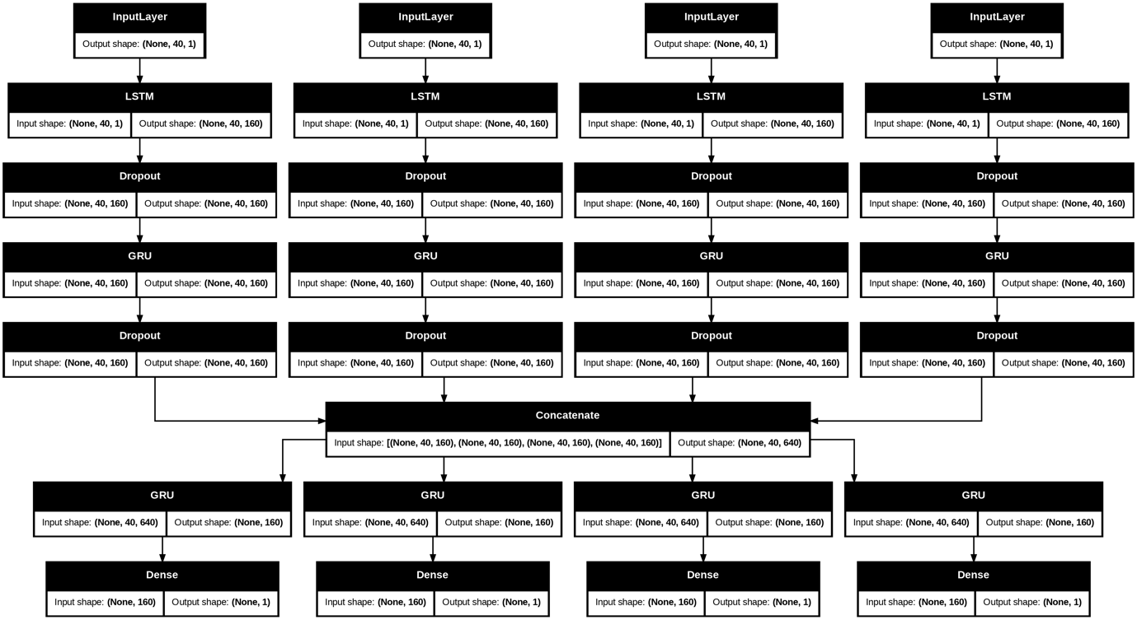
Fig 1: LSTM – GRU. Inputs pass through an LSTM layer, then a GRU layer.

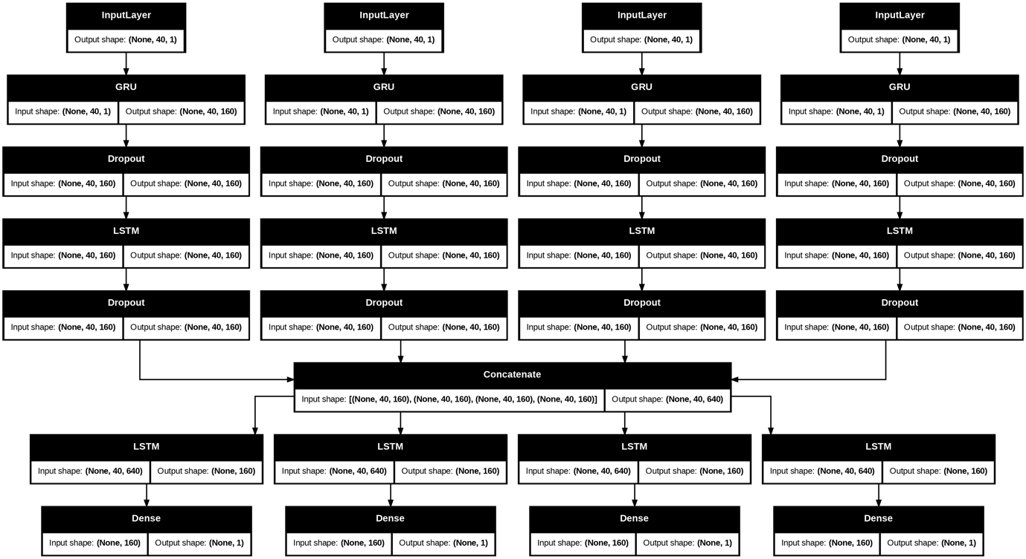
Fig 2: GRU – LSTM model. Inputs first pass through a GRU, followed by an LSTM.

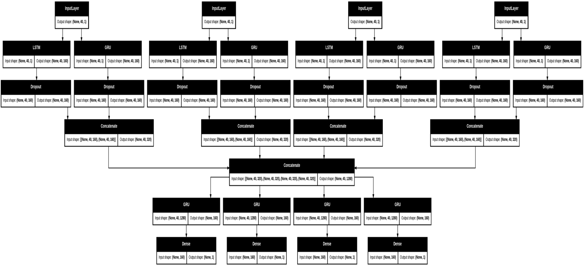
Fig 3: LSTM + GRU in parallel. Inputs are processed simultaneously through LSTM and GRU branches, with their outputs concatenated before dense prediction layers.

The study explored four primary neural network block architectures for multi-stock prediction tasks, each with a progressively refined structure. The first, termed the Direct model, consists of independent neural networks trained on each stock's input data. The outputs from these individual networks are then concatenated into a single merged layer. From this shared representation, the model branches into four distinct dense layers each tasked with predicting one specific stock. This architecture serves as a baseline for comparison with more complex designs.
Building upon this, the Downsizing model introduces a recurrent neural network (RNN) layer directly after the concatenation layer. This added RNN layer enables the model to capture temporal dependencies and cross-stock interactions more effectively. The Tuned-Downsizing model further extends this design by incorporating a dropout layer after the RNN. The dropout introduces stochastic regularisation, which helps mitigate overfitting and improves generalisation across different stocks. Lastly, the Stabilised-Downsizing model replaces the dropout layer with another RNN, adding further sequence modelling capabilities. This modification seeks to increase stability during training while maintaining temporal recall in the model’s internal representations. Each of these architectures processes input time-series data from multiple stocks in parallel. The weighted outputs are then concatenated and subsequently distributed into stock specific output layers. The primary differences across models lie in how they utilise the concatenated representation, whether by applying further RNN layers or adding regularisation strategies like dropout.
Each model takes an individual input from each stock and learns from it, these weighted outputs are then concatenated to make the first model. The concatenated layer is then split into 4 dense layers that predict each individual stock. The other three models differ by adding extra layers after concatenation and before the dense outputs. Similar to Karevan et al. (2018) where separate LSTMs processed the inputs of one of the models implemented in this study involved parallel processing of the inputs. One branch is an LSTM, the other a GRU, both RNNs to process each stock. The results were then merged and then split to make those individual predictions. This was the basis for the parallel hybrid model.
Additionally, two extended models were implemented to explore more advanced sequence learning techniques. The first is a Hybrid + Attention model, which integrates temporal attention mechanisms into the hybrid RNN architecture. This attention layer enables the model to dynamically focus on the most relevant timesteps within each 40-day input window, allowing it to weigh critical periods more heavily in making predictions. By highlighting key temporal features, the attention mechanism aims to improve the model’s ability to capture important patterns and dependencies that might otherwise be diluted in longer sequences. Attention was implemented across all established models to observe the inter-architectural differences.
The second extended model is a Transformer Baseline, which employs a compact encoder-only Transformer architecture with positional embeddings. Transformers, known for their success in natural language processing, utilise self-attention mechanisms to model relationships between all elements of the input sequence simultaneously, rather than sequentially. This model serves as a modern benchmark for sequence learning, offering a contrast to the recurrent approaches. The inclusion of positional embeddings ensures that the model retains awareness of the order of inputs, which is crucial for time-series data such as stock prices.

Company Grouping
The selection of companies for this study was guided by the need to capture representative technical price behaviours within the NASDAQGS stock market, while also ensuring diversity across different industry segments. The historical price data was sourced from Yahoo! Finance, which provides publicly available stock market information.
Initially, the companies included were Amazon (AMZN), Alphabet (GOOGL), Qualcomm (QCOM), and Ball Corporation (BLL). AMZN, GOOGL, and QCOM are all listed on the NASDAQGS, while BLL, which was renamed to BALL in May 2022, trades exclusively on the New York Stock Exchange (NYSE). Although Marvell Technology (MRVL) was considered as a potential substitute to maintain consistency by focusing solely on NASDAQGS-listed stocks, Ball Corporation (BALL) was ultimately retained in the dataset. Keeping BALL ensured continuity across the full historical window and avoided complications related to reselecting and rebalancing the stock groups midway through the project. While this decision introduced some heterogeneity, since BALL trades on the NYSE whereas the other three stocks are listed on the NASDAQGS, it provided a stable dataset and preserved the integrity of the original stock grouping design.
The final dataset, therefore, consists of the following companies:

- AMZN (Amazon, large-cap, NASDAQGS)
- GOOGL (Alphabet, large-cap, NASDAQGS)
- QCOM (Qualcomm, mid-cap, NASDAQGS)
- BALL (Ball Corp, mid-cap, NYSE)
The values of AMZN and GOOGL were multiplied by 20 to get the unadjusted prices, as GOOGL and AMZN stocks were split 20:1 in May 2022; also, BLL (later renamed to BALL) had a 2:1 split on the 17th of May 2017. QCOM's last stock split was in 2004, so it was not included.

Performance Metrics
To evaluate the predictive performance of the models, several complementary metrics were employed. Root Mean Squared Error (RMSE) and Mean Absolute Error (MAE) were selected as they provide direct measures of the average prediction error in absolute terms. RMSE, in particular, penalises larger deviations more heavily due to the squaring operation, making it useful in financial forecasting where occasional large errors can be costly. MAE, by contrast, gives a more balanced picture of typical error magnitude, ensuring that performance is not overly dominated by outliers.
The Mean Absolute Percentage Error (MAPE) was also reported, as it offers an interpretable, scale-independent measure of predictive accuracy expressed as a percentage. This is particularly useful when comparing predictions across stocks with very different price levels, such as large-cap technology firms versus mid-cap industrial or semiconductor firms. However, MAPE has limitations when true values are close to zero, as percentage errors can become disproportionately inflated. This follows Lawi et al. (2022) approach.
In addition to these error-based measures, the coefficient of determination (R²) was calculated to capture how much of the variance in the stock price series the model was able to explain. A higher R² indicates that the model successfully captured temporal dependencies and structural patterns in the data. Directional accuracy, defined as the percentage of times the model correctly predicted whether the next day’s price would increase or decrease, was also considered. This measure is particularly relevant in financial contexts, where the direction of movement is often more important than the exact predicted value. While these metrics together provide a balanced assessment of model accuracy, they are not without limitations. Error-based measures treat over-predictions and under-predictions symmetrically, which does not reflect the asymmetric risks present in financial trading. In future research, it may be beneficial to incorporate profit-oriented evaluation criteria such as simulated trading returns, the Sharpe ratio, or maximum drawdown, which capture the economic consequences of prediction errors.

Results
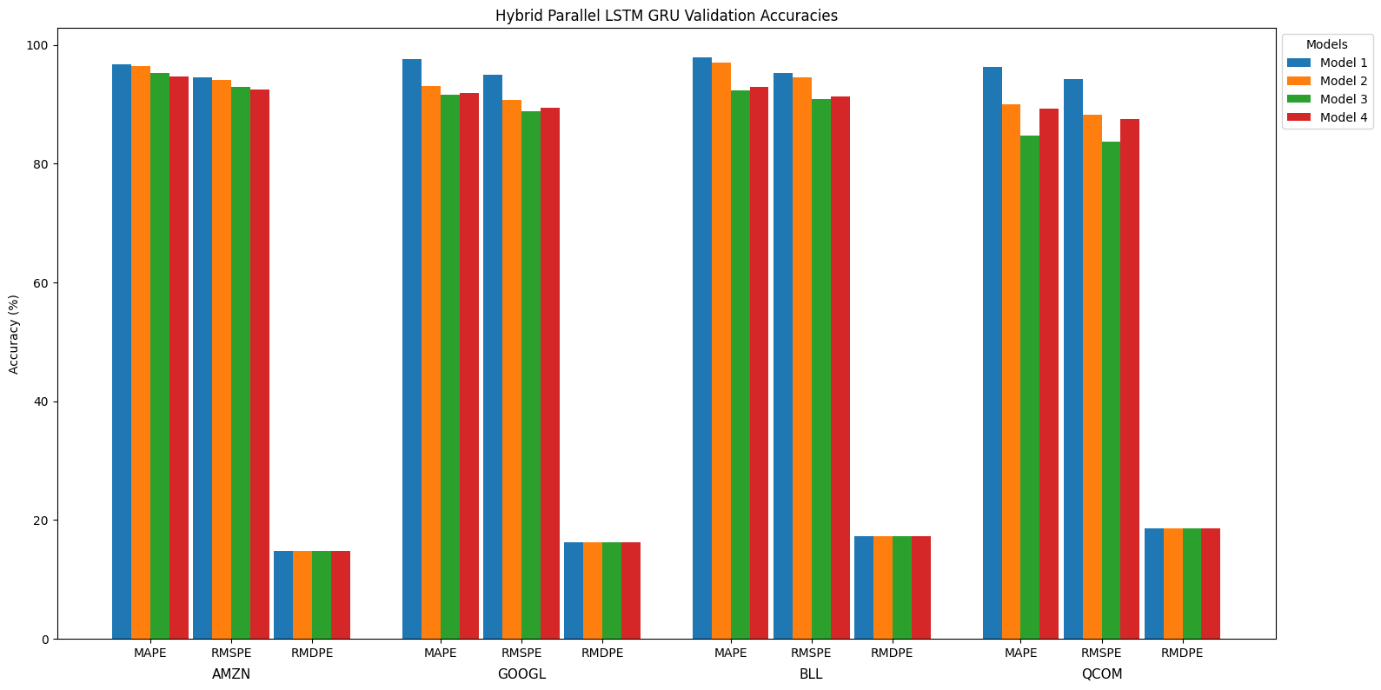
Fig 4: Parallel LSTM GRU validation accuracy.

The highest performing model was the parallel LSTM + GRU architecture. For Amazon (AMZN), the Percentage Error (MAPE) increases from 5.31% in model 1 to 9.57% in model 4, while the Root Mean Square Percentage Error (RMSPE) rises from 7.34% to 10.86%. The Relative Median Deviation Percentage Error (RMDPE) remains constant at 85.22 across all models. This suggests that Model 1 achieves the strongest predictive accuracy for AMZN, with performance steadily declining as the models progress.
In the case of Google (GOOGL), there is a sharper reduction in accuracy compared to AMZN. MAPE rises from 8.50% in model 1 to a peak of 11.57% in model 4, with a slight improvement in model 2 to 6.05%. RMSPE follows a similar pattern, increasing from 10.90% to 13.91%, with a low point at 8.40% in model 2. RMDPE remains stable at 83.82 across all models. These results confirm that model 1 and model 2 perform better than later variants, while models 3 and 4 result in reduced accuracy, despite the temporary improvement in model 2.
For Ball Corporation (BLL), the models display some variability but generally maintain strong predictive performance. MAPE increases from 3.35% in model 1 to 7.87% in model 3, before improving significantly to 2.77% in model 4. RMSPE moves from 5.62% to 9.17%, then decreases to 5.38% in the final model. RMDPE remains constant at 82.78. This pattern suggests that model 4 yields the best results for BLL, with models 2 and 3 introducing accuracy losses relative to the first and last models.
The results for Qualcomm (QCOM) show notable volatility. MAPE increases from 4.13% in model 1 to a high of 11.60% in model 3, before falling back to 6.15% in model 4. RMSPE follows the same trend, rising from 6.15% to 12.75%, then decreasing to 7.88%. RMDPE is stable at 81.50 across all models. Here, model 1 achieves the best performance overall, while model 3 produces the weakest results, highlighting instability in predictive accuracy for QCOM.
Overall, the results indicate that the parallel LSTM + GRU architecture achieves its highest accuracy primarily in the earlier models across all four stocks, particularly model 1. Later model variants generally reduce predictive performance, with some rebounds observed in models 2 and 4 depending on the stock. The constant RMDPE values per company suggest this metric reflects inherent dataset characteristics more than model variation. Among the stocks, AMZN shows a steady decline in accuracy, GOOGL experiences moderate drops with a partial recovery, BLL benefits from model 4’s improvements, and QCOM displays the most pronounced fluctuations with model 3 performing particularly poorly.
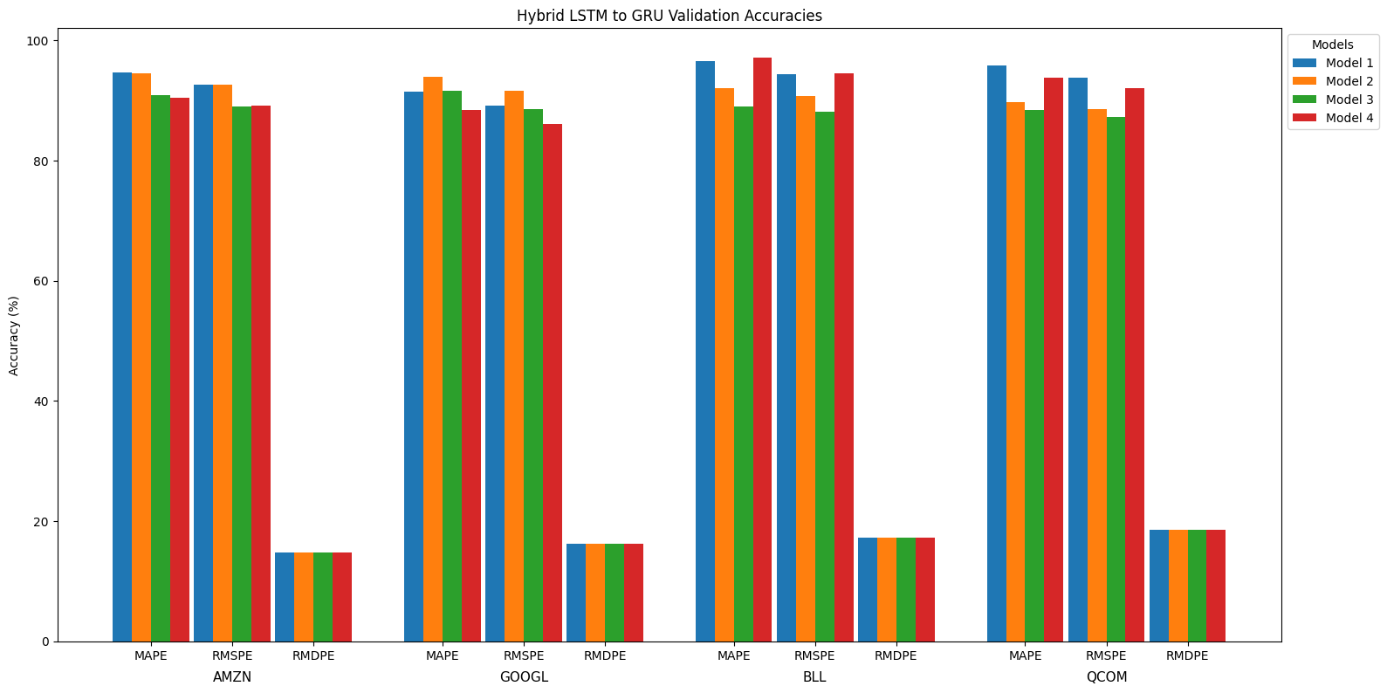
Fig 5: Hybrid LSTM to GRU validation accuracy.

The performance of the LSTM to GRU models varied across companies and model iterations. For AMZN, the highest accuracies were observed in model 3 (94.69% MAPE accuracy and 92.66% RMSPE accuracy), although subsequent models showed a decline, with model 6 dropping to around 90%. GOOGL displayed similar behaviour, achieving stronger results in the earlier models (over 93% MAPE accuracy in model 4) but declining towards model 6, where accuracy fell to around 88%. BLL exhibited notable variability: models 3 and 5 produced weaker results (around 89% MAPE accuracy), but model 6 sharply improved, delivering the strongest outcome across all stocks with a MAPE accuracy of 97.23% and RMSPE accuracy of 94.62%. QCOM showed instability as well, with model 3 accuracy dropping to 88.4%, then rebounding in model 6 to over 93.8%.
Overall, the first two models tend to perform best for AMZN and GOOGL, while BLL and QCOM show greater fluctuations across models. Model 6 demonstrates particularly strong recovery for BLL and QCOM, highlighting that later architectures can outperform earlier ones in some cases despite the general trend of declining accuracy. RMDPE values remain constant within each company, suggesting this metric reflects inherent dataset characteristics rather than differences in model design. These results indicate that while LSTM + GRU hybrids can capture temporal dependencies effectively, their performance is highly sensitive to the specific model variant and stock dataset under consideration.
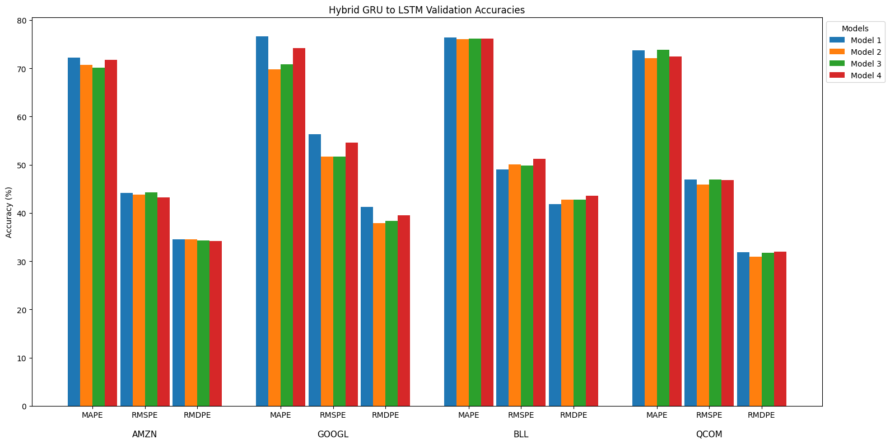
Fig 6: Hybrid GRU to LSTM validation accuracy.

The highest performing model among the GRU variants was Model 1, though overall accuracy is notably lower compared to the parallel LSTM + GRU models. For Amazon (AMZN), the performance shows a gradual decline across the four variants. The Mean Absolute Percentage Error (MAPE) increases from 27.80% in model 1 to 29.82% in model 3 before slightly improving to 28.21% in model 4. Similarly, the Root Mean Square Percentage Error (RMSPE) remains high, fluctuating around 55-57%, with a small dip in model 3. The Relative Median Deviation Percentage Error (RMDPE) stays fairly constant at about 65.5 across all models. This suggests that model 1 delivers the best predictive accuracy for AMZN, with only minor performance variations thereafter.
In the case of Google (GOOGL), the decline in accuracy is more pronounced. MAPE increases from 23.32% in model 1 to a peak of 30.19% in model 2, before dropping back to 25.77% in model 4. RMSPE follows a similar trajectory, rising from 43.61% to 48.33% then falling to 45.36%. RMDPE remains steady around 58-62% throughout. These results highlight that model 1 performs relatively well, but subsequent models tend to fluctuate more widely in their predictive accuracy, with model 4 showing some recovery.
For Ball Corporation (BLL), the models show a relatively stable pattern with minor fluctuations. MAPE hovers around 23.6% in model 1 and model 3, slightly increasing to 23.93% in model 2 and decreasing marginally to 23.83% in model 4. RMSPE varies between 49.97% and 51.25%, while RMDPE consistently stays near 56-58%. This stability suggests that all GRU models perform similarly on BLL, with no substantial accuracy gains or losses across variants.
The results for Qualcomm (QCOM) demonstrate some volatility but maintain a relatively consistent range. MAPE fluctuates between 26.15% and 27.94%, RMSPE varies between 53% and 56.7%, and RMDPE remains steady around 68%. Model 1 shows the strongest accuracy, while model 2 presents the weakest results, though differences are not drastic. These fluctuations point to moderate instability in model performance for QCOM across the GRU variants.
The hybrid architectures, LSTM to GRU and GRU to LSTM, were introduced to explore whether combining the strengths of both recurrent units could improve prediction accuracy across grouped stock data. The LSTM to GRU configuration was designed to allow the model to first leverage the long-term memory retention capabilities of LSTM layers, followed by the computational efficiency and faster pattern recognition of GRUs. Conversely, the GRU to LSTM structure applies GRU layers initially to capture short-term dependencies quickly, before passing the processed sequence into LSTM layers that are better suited to learning from extended temporal patterns. While both hybrid types aimed to balance speed and depth in sequential learning, their performance varied, and results suggest that the order of operations significantly influences predictive success.
Between the two hybrid forms, the LSTM to GRU models consistently outperformed the GRU to LSTM models, particularly in terms of RMDPE. This can be attributed to the LSTM's ability to establish a strong temporal foundation in the early stages of the model. By encoding long-term patterns and relevant context before GRU layers refine and condense the learned representations, the model avoids prematurely discarding potentially important information. In contrast, GRU to LSTM models seem to suffer from early-stage information loss. The GRU layers, while efficient, may oversimplify or overlook complex temporal dependencies when positioned at the front of the model. As a result, by the time the LSTM layer attempts to build long-term representations, much of the nuanced temporal structure has already been filtered out or attenuated, limiting the LSTM’s effectiveness.
Moreover, the RMDPE metric provides valuable insight into this phenomenon. Since RMDPE emphasises the model's ability to handle median deviations, which often reflect rare but impactful fluctuations in stock price, it then becomes clear why LSTM-GRU performs better. Outliers and sudden market shifts are better captured when early layers retain detailed temporal memory. The GRU-LSTM models, by contrast, present elevated RMDPE values, likely due to their inability to recover contextual information that was not preserved during the GRU’s initial processing. In high-volatility or irregular stock patterns, this loss becomes especially detrimental, explaining the underperformance seen in stocks like AMZN and GOOGL.

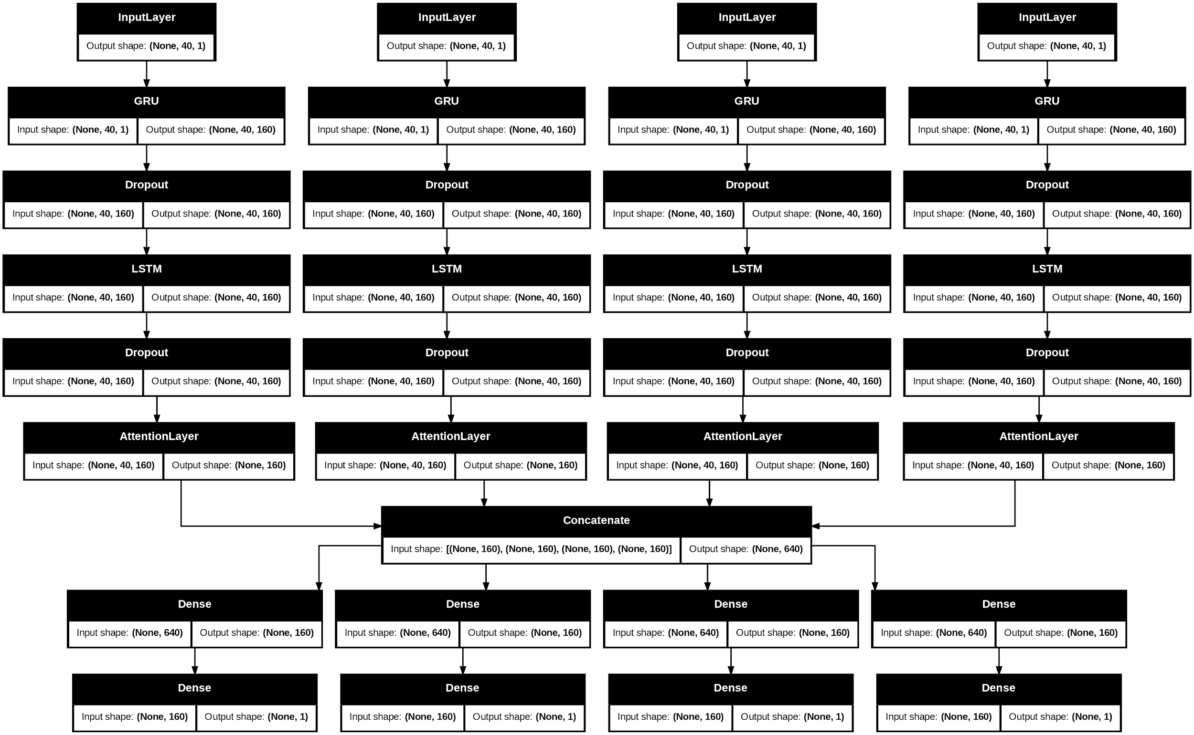
Fig 7: Example of GRU – LSTM architecture with an attention layer in each branch to learn stock-specific history.

In summary, while both hybrid approaches aim to combine the strengths of their individual components, the LSTM-GRU configuration is more effective when modelling complex financial time-series data. It demonstrates better handling of long-term dependencies and irregular patterns, as reflected in more favourable RMDPE and overall accuracy scores. The GRU-LSTM structure, though conceptually promising, may require additional tuning or architectural modifications to avoid premature information loss. These findings reinforce the importance of sequence architecture design when working with grouped time-series data and highlight how small changes in model structure can lead to significantly different outcomes, particularly in volatile or outlier-prone financial environments.
The addition of attention mechanisms aimed at capturing inter-stock historical relationships appears to have negatively impacted the model’s learning capabilities. Instead of enhancing prediction accuracy, the attention seems to cause the model to generalise across multiple stocks, resulting in smoothed, averaged predictions that lose the distinct characteristics of each stock. This blending reduces the model’s ability to capture the unique patterns and behaviours specific to individual stocks.
One likely cause of this issue is the initial grouping of stocks based primarily on earnings categories, such as separating high-earning from low-earning firms. While this classification captures a broad economic distinction, it does not adequately reflect the statistical properties of financial time series. Stocks with vastly different absolute price levels, volatility profiles, or liquidity patterns present a significant challenge when fed into a shared representation without rigorous preprocessing. For example, a high-priced stock such as Alphabet, with stable yet gradual movements, will exhibit very different statistical dynamics compared to a more volatile mid-cap stock like Ball Corporation. If both are grouped solely by earnings, the model is forced to reconcile incompatible signals. In this scenario, the attention mechanism, rather than isolating meaningful cross-stock relationships, may amplify irrelevant fluctuations. This leads to the introduction of noise and spurious dependencies, which ultimately weakens predictive performance. In essence, the mismatch between grouping criteria and preprocessing strategy constrains the model, preventing it from exploiting the true potential of attention-based architectures.
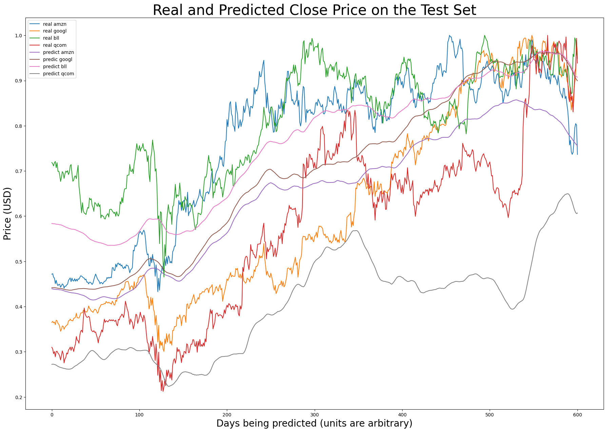
Fig. 8: Parallel hybrid LSTM GRU prediction with attention mechanisms. Shows the blending of predictions between the stocks.

This finding underscores the importance of aligning data preparation with model design in financial deep learning. Attention mechanisms are not inherently ineffective; rather, their success depends on a preprocessing pipeline that creates comparable, interpretable feature spaces across assets. Grouping stocks based on similarities in volatility clustering, autocorrelation structures, or return distributions would likely yield more coherent joint dynamics than relying on earnings categories alone. Likewise, careful normalisation across heterogeneous series, whether through per-stock scaling, volatility adjustment, or transformation to log returns, can mitigate distortions introduced by scale differences. Ultimately, this suggests that attention mechanisms should be applied with greater caution and more thoughtful data preparation in financial time-series modelling. Proper grouping based on statistical behaviour and data scale, along with preprocessing strategies that preserve each stock’s internal dynamics, can allow models to capture genuine interdependencies while avoiding the pitfalls of blending unrelated patterns. Without such considerations, attention risks diluting rather than enhancing predictive signals, producing degraded model performance where improvements were anticipated.
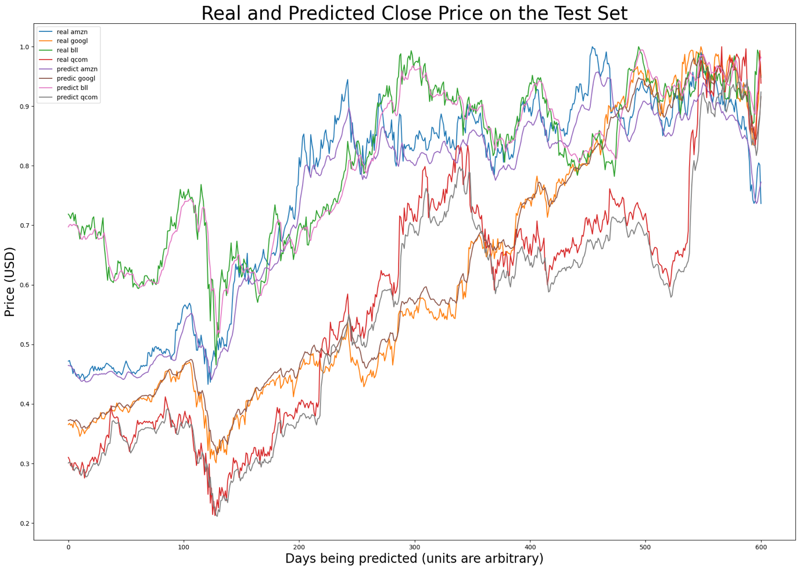Fig. 9: Parallel hybrid LSTM GRU prediction without attention mechanisms.

Future work could therefore explore more principled grouping and preprocessing strategies to unlock the benefits of attention in financial forecasting. One promising avenue is sector- or industry-based grouping, which aligns stocks with comparable market drivers and reduces the risk of introducing incompatible dynamics. Alternatively, unsupervised clustering techniques such as k-means or hierarchical clustering applied to volatility features, autocorrelation statistics, or rolling correlation matrices could dynamically group assets based on their observed time-series behaviour rather than static financial categories. Transformations such as log returns or volatility-normalised series may further stabilise scale differences and highlight relative rather than absolute movements. By combining these approaches, future studies could construct attention-ready datasets that maximise both cross-stock comparability and temporal interpretability. Such designs would help clarify whether the limited effectiveness of attention in the present study is a consequence of model architecture, data preparation, or an interaction of the two, thereby laying the groundwork for more robust and interpretable financial forecasting systems.
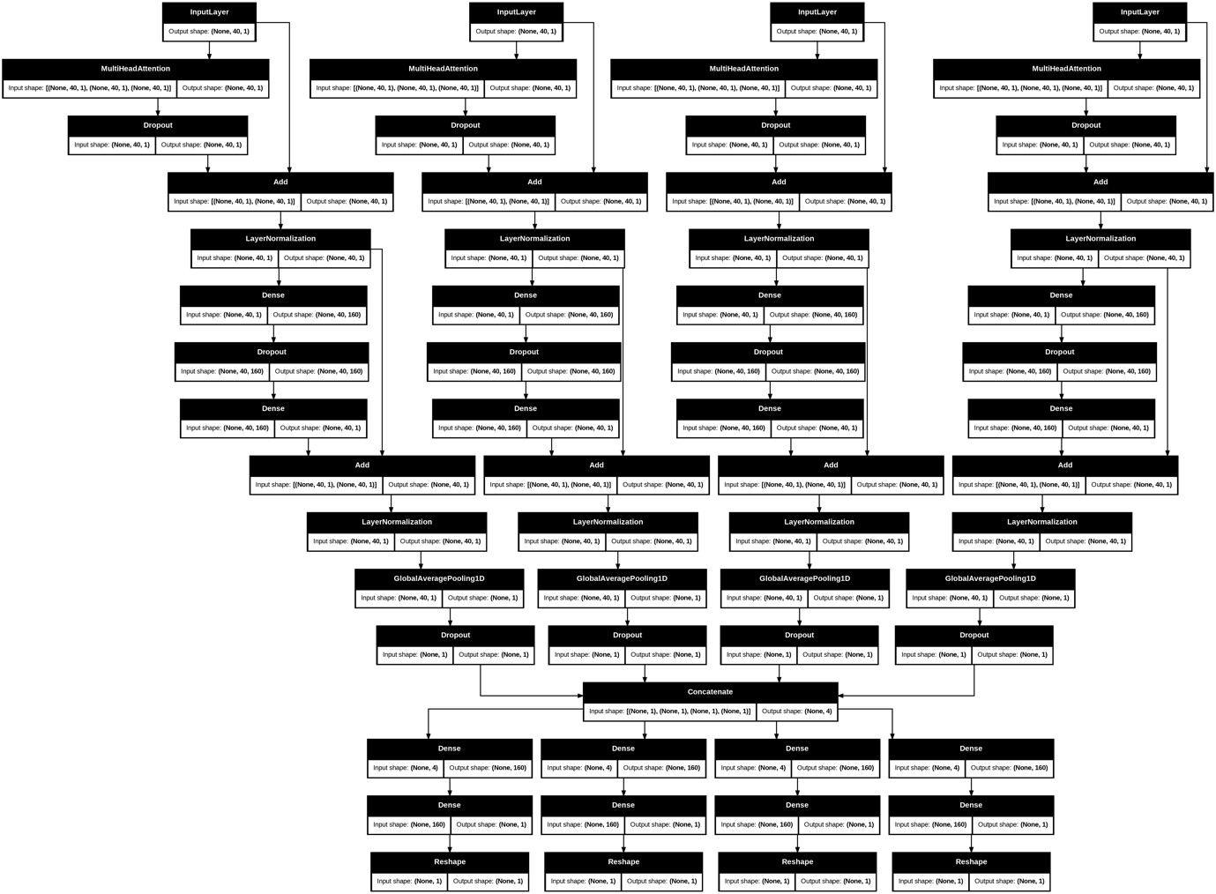
Fig 10: Transformer model architecture as a benchmark

The Transformer model was introduced as a benchmark to compare the performance of recurrent architectures against a modern sequence modelling approach. Its encoder-based structure (Fig. 10) was designed to process the same 40-day input windows as the RNN variants, with positional encodings compensating for the absence of recurrence. Despite its success in natural language processing and certain time-series applications, the Transformer struggled in this financial forecasting context. Trained under identical preprocessing and evaluation settings, the model failed to capture the subtle temporal dependencies and regime shifts present in the stock data.
As shown in Fig. 11, the predictions produced by the Transformer exhibited smoothed trajectories that did not track day-to-day fluctuations accurately. This suggests that, given the modest dataset size and relatively short sequence length, the self-attention mechanism may have been insufficiently constrained, leading to overgeneralisation and a lack of responsiveness to local price movements. These results indicate that while Transformers remain powerful in theory, their advantages are not automatically realised in small-sample, high-noise financial datasets without substantial adaptation, such as pretraining on larger market corpora or incorporating specialised time-series embeddings.
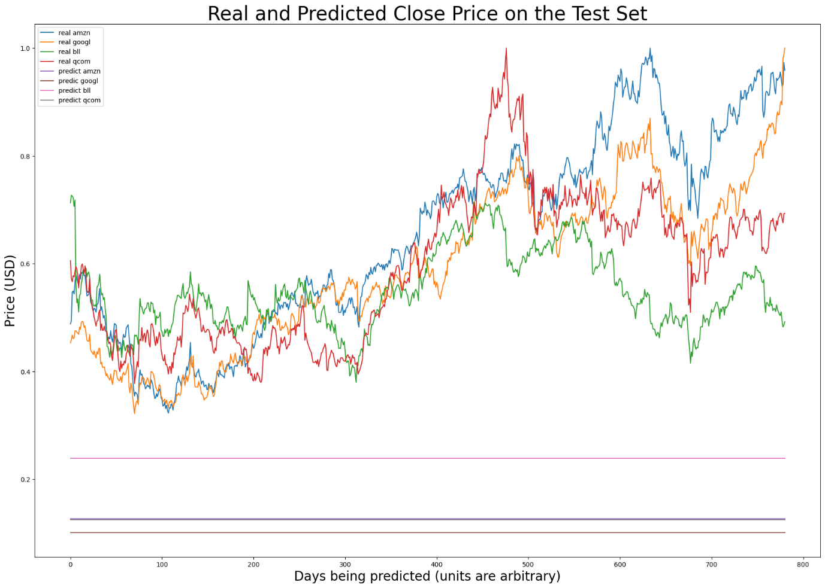
Fig 11: Transformer Predictions were unable to capture movement in the data

Conclusion
This research set out to investigate the effectiveness of hybrid recurrent neural network architectures, specifically LSTM, GRU, and their combinations augmented with attention mechanisms, in forecasting grouped financial time series data. Building upon the foundational work of Lawi et al. (2022), who demonstrated the comparative advantages of GRUs over LSTMs in grouped settings, this study extended the scope by incorporating hybrid models, sliding window evaluation, and a baseline Transformer model. The intent was not only to assess predictive accuracy across multiple architectures but also to test the limits of attention based interpretability and to examine whether Transformer based models could realistically be applied in resource constrained scenarios. This broader perspective proved important because it highlighted not only which models performed best but also which approaches were less suited to financial time series forecasting.
The results showed that among all models tested, the parallel LSTM GRU model consistently delivered the highest accuracy across the four selected NASDAQGS stocks (AMZN, GOOGL, BLL, and QCOM). This hybrid structure appeared to take advantage of the complementary strengths of both RNN types: the LSTM’s ability to capture long term dependencies and the GRU’s efficiency in filtering out noise through its simpler gating mechanisms. In practice this meant the hybrid model was better able to identify patterns across the 40 day input windows even when the underlying stock dynamics varied significantly. In contrast, the models that incorporated attention mechanisms or Transformer based architectures performed considerably worse. Attention in particular led to predictions that converged toward flattened averages rather than reflecting meaningful market movements. This outcome was an early indication that the way attention was implemented in this project, spanning across stocks grouped by earnings category, was fundamentally misaligned with the realities of the data.
A critical observation was that the grouping strategy and preprocessing design had a decisive impact on performance. By grouping stocks primarily on earnings categories, the models were encouraged to treat equities with very different price scales and volatility behaviours as though they were comparable. While this grouping made sense from a financial perspective, it was poorly matched to the assumptions required by attention based models. Instead of highlighting important temporal features within each stock, the attention layers effectively forced the models to generalise across heterogeneous data. The result was an averaging effect where stock specific patterns were lost. This suggests that in financial applications attention mechanisms must be applied with much more care, either restricted to single ticker data or combined through a higher level structure that preserves differences between equities. Without this step, attention risks amplifying noise and obscuring useful signals.
In hindsight, the preprocessing design played an equally central role in shaping the outcomes. While per ticker MinMax scaling helped the recurrent models by normalising their inputs, attention based and Transformer models implicitly assumed that all series operated on a comparable scale. This assumption was not valid and it led to imbalances in how the models assigned importance to input features. The problem was not simply one of poor accuracy but also of interpretability: attention visualisations, which should highlight which time steps mattered most, ended up producing patterns that were incoherent and inconsistent with known market behaviours. This highlights the point that interpretability tools in machine learning are only as reliable as the data preparation that supports them. Unless the preprocessing is aligned with the model’s design, the resulting explanations may be misleading rather than insightful.
The Transformer baseline, despite its reputation as a state of the art model in many sequence learning domains, was another area where the results did not meet expectations. Although theoretically powerful, the compact encoder only implementation used here lacked the depth and receptive field necessary to model longer term dependencies effectively. Even with positional encodings included, the model struggled with the relatively short 40 day input windows. Transformers typically excel when exposed to very large datasets and long contexts, such as entire documents in natural language processing, and so their weaknesses in this study reflected both the narrow data window and the noisy, non stationary nature of financial series. The experience also underscored why these difficulties arose. Attention and Transformer models assume structured, internally consistent sequences, such as words in a sentence, while financial data is volatile, irregular, and highly non stationary. Without sufficient data volume, longer input sequences, or advanced embeddings, these architectures tended to overgeneralise and underperform, highlighting a mismatch between model design and data characteristics.
The process of implementing and adapting the more complex models, especially those involving attention and Transformer mechanisms, also highlighted practical challenges. The experimental framework had to be restructured multiple times, moving from a condensed draft notebook that attempted to test all models at once to a modular system that better separated model types and training routines. This restructuring improved clarity and reproducibility, but it also revealed that some goals, such as producing clear attention based visualisations of temporal dependencies, were less achievable when predictive accuracy was poor. By contrast, hybrid recurrent models proved better suited to the modest dataset size and sliding window design, striking a balance between expressiveness and stability that the Transformer architecture struggled to achieve. These observations reinforced the importance of matching model design to data conditions rather than assuming that methods successful in one domain will transfer seamlessly to another.
Looking forward, several directions for future research are clear. Attention could be reintroduced in a more controlled manner, applied only within single ticker sequences or through hierarchical structures that separate ticker level from group level signals before integration. Transformers could also be revisited under conditions more favourable to their strengths, such as larger datasets, longer horizons in the range of 120 to 200 days, and potentially pretraining on broader financial corpora before fine tuning. Future work might also explore hybrid encoders, combining RNNs for local dynamics with Transformer style decoders for longer range dependencies, or embedding domain specific biases such as volatility clustering and regime switching mechanisms. Finally, interpretability should remain a priority, with attention visualisations or saliency methods evaluated not only for clarity but also for their alignment with known market phenomena, ensuring that future models provide not just accurate forecasts but also insights into the drivers of financial behaviour.
Despite the setbacks, several valuable insights emerged. Chief among these was the importance of matching model design to the characteristics of financial data. Attention mechanisms and Transformers thrive in contexts where inputs are consistent and semantically meaningful, as in language. In finance however, inputs are noisy, highly variable, and affected by sudden regime shifts. This mismatch demands either more thoughtful preprocessing, such as grouping by volatility and scaling behaviour rather than earnings, or more careful application of these models at the level of individual stocks before aggregating insights. Additionally, the failure of the Transformer baseline suggests that such models require either longer time horizons or broader datasets to be competitive in this space. Future research could address these limitations by extending input windows, expanding the stock universe, or applying pretraining techniques to capture general market behaviours before focusing on individual equities.
In conclusion, while this study did not demonstrate the superiority of attention or Transformer based models, it confirmed the robustness of hybrid recurrent neural networks, particularly the parallel LSTM GRU structure, for grouped financial forecasting. The experience underscored both the potential and the pitfalls of adapting deep learning innovations from other domains into finance. Where the study succeeded in refining and extending the baseline framework, in validating the effectiveness of hybrid recurrent designs, and in identifying preprocessing as a critical determinant of performance, it provides a strong foundation for further research. Where it fell short, in the implementation of attention, in the limited success of Transformers, and in the difficulty of generating meaningful interpretability, it highlights the importance of careful alignment between data, model assumptions, and evaluation strategies. Taken together, these lessons argue for a cautious but creative approach to future work: experimenting with hierarchical attention, ticker specific Transformers, or hybrid encoder decoder models, but always with an awareness of the unique challenges posed by financial data.

Rights and permissions
Open Access The original article (Lawi et al, 2022) is licensed under a Creative Commons Attribution 4.0 International License, which permits use, sharing, adaptation, distribution and reproduction in any medium or format, as long as you give appropriate credit to the original author(s) and the source, provide a link to the Creative Commons licence, and indicate if changes were made. The images or other third-party material in this article are included in the article's Creative Commons licence, unless indicated otherwise in a credit line to the material. If material is not included in the article's Creative Commons licence and your intended use is not permitted by statutory regulation or exceeds the permitted use, you will need to obtain permission directly from the copyright holder. To view a copy of this licence, visit http://creativecommons.org/licenses/by/4.0/.
Reprints and permissions

References
YFinance API Full PythonTutorial https://www.youtube.com/watch?v=j0sBKAB75oc
Lawi, A., Mesra, H. & Amir, S. (2022). Implementation of Long Short-Term Memory and Gated Recurrent Units on grouped time-series data to predict stock prices accurately. J Big Data 9, 89 https://doi.org/10.1186/s40537-022-00597-0
Thomas Hollis, Antoine Viscardi, Seung Eun Yi. (2018) A Comparison of LSTMs and Attention Mechanisms for Forecasting Financial Time Series, ArXiv https://doi.org/10.48550/arXiv.1812.07699
Yunita A, Pratama MI, Almuzakki MZ, Ramadhan H, Akhir EAP, Firdausiah Mansur AB, Basori AH. (2025) Performance analysis of neural network architectures for time series forecasting: A comparative study of RNN, LSTM, GRU, and hybrid models. MethodsX. doi: 10.1016/j.mex.2025.103462. PMID: 40777584;
Hochreiter, S., & Schmidhuber, J. (1997). Long short-term memory. Neural Computation, 9(8), 1735–1780. https://doi.org/10.1162/neco.1997.9.8.1735
Cho, K., van Merriënboer, B., Gulcehre, C., Bahdanau, D., Bougares, F., Schwenk, H., & Bengio, Y. (2014). Learning phrase representations using RNN encoder–decoder for statistical machine translation. arXiv preprint arXiv:1406.1078.
Greff, K., Srivastava, R. K., Koutník, J., Steunebrink, B. R., & Schmidhuber, J. (2017). LSTM: A search space odyssey. IEEE Transactions on Neural Networks and Learning Systems, 28(10), 2222–2232. https://doi.org/10.1109/TNNLS.2016.2582924
Mienye, I. D., Swart, T. G., & Obaido, G. (2024). Recurrent Neural Networks: A Comprehensive Review of Architectures, Variants, and Applications. Information, 15(9), 517. https://doi.org/10.3390/info15090517
Zara Karevan, Johan A., K. Suykens (2018) Spatio-temporal Stacked LSTM for Temperature Prediction in Weather Forecasting. ArXiv, https://arxiv.org/abs/1811.06341 [Accessed 15 August 2025].
Hyndman, R. J., & Athanasopoulos, G. (2018). Forecasting: principles and practice.
Niu, Z., Zhong, G., & Yu, H. (2021). A review on the attention mechanism of deep learning. Neurocomputing, 452, 48-62. https://doi.org/10.1016/j.neucom.2021.03.091 [Accessed 15 August 2025].
Vaswani, A., Shazeer, N., Parmar, N., Uszkoreit, J., Jones, L., Gomez, A.N., Kaiser, Ł. & Polosukhin, I., (2017). Attention is all you need. In: NIPS 2017: Advances in Neural Information Processing Systems. Long Beach, California, USA,. Available at: https://arxiv.org/abs/1706.03762 [Accessed 28 August 2025].
Zhang, Zihao and Zohren, Stefan and Roberts, Stephen, (2020). Deep Learning for Portfolio Optimisation. http://dx.doi.org/10.2139/ssrn.3613600
Mirete-Ferrer, P. M., Garcia-Garcia, A., Baixauli-Soler, J. S., & Prats, M. A. (2022). A Review on Machine Learning for Asset Management. Risks, 10(4), 84. https://doi.org/10.3390/risks10040084
Xavier Amatriain, Ananth Sankar, Jie Bing, Praveen Kumar Bodigutla, Timothy J. Hazen, Michaeel Kazi (2024). Transformer models: an introduction and catalog. arXiv:2302.07730. https://doi.org/10.48550/arXiv.2302.07730
Hussin Ragb , Akram Muntaser , Elforjani Jera , et al. (2023) Hybrid GRU-LSTM Recurrent Neural Network-Based Model for Real Estate Price Prediction. TechRxiv. DOI: 10.36227/techrxiv.21929760.v1
Bergmeir, C., Hyndman, R. J., & Koo, B. (2018). A note on the validity of cross-validation for evaluating autoregressive time series prediction. Computational Statistics & Data Analysis, 120, 70–83. https://doi.org/10.1016/j.csda.2017.11.003
Makridakis, S., Spiliotis, E., & Assimakopoulos, V. (2018). The M4 competition: Results, findings, conclusion and way forward. International Journal of Forecasting, 34(4), 802–808. https://doi.org/10.1016/j.ijforecast.2018.06.001

Code
GroupPredict_LSTM_GRU.ipynb: https://drive.google.com/file/d/1bunCtcSIpJVgfHQG56AbYW0XD7ML926q/view?usp=drive_link
GroupPredict_GRU_LSTM.ipynb: https://drive.google.com/file/d/1cCVJHBF2tfiVnKBp-0fOaq2avwT7EKmo/view?usp=drive_link
GroupPredict_hybrid_LSTMGRU.ipynb: https://drive.google.com/file/d/14fCxjE8bRgtgduPlG01EJIzV-0gMm5ND/view?usp=drive_link
draft.ipynb: https://colab.research.google.com/drive/1Vg8jB4jWLnHNUuKoAWcTXJhVbkqopxe3?usp=drive_link

